**WORK EXPERIENCE**

**HOLCRUSH.com**

This website (url: <https://holcrush.com/> ) is completely designed and developed by me. Logo, Pictures were edited according to the need of the website everything was designed in my manner.

For a better understanding visit the website url: <https://holcrush.com/>

Mymaaya.com

This website (url: <https://mymaaya.com/> ) is completely designed and developed by me. For a better understanding visit the website url: <https://mymaaya.com/>

7skieswood.**com**

This website (url: <https://www.7skieswood.com/> ) is completely designed and developed by me. For a better understanding visit the website url: <https://www.7skieswood.com/>

Home Page

Home Page

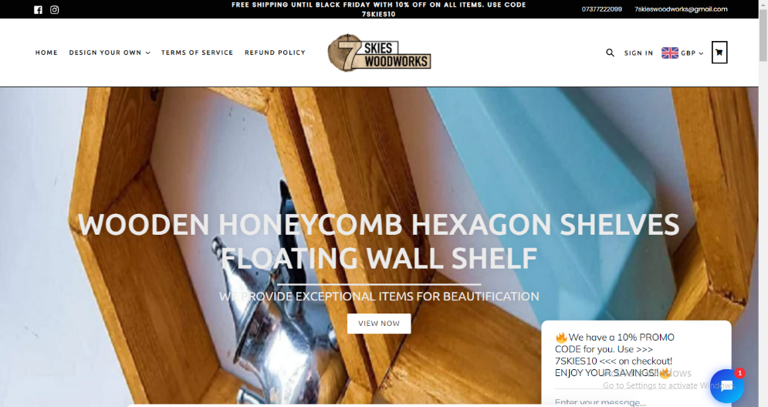

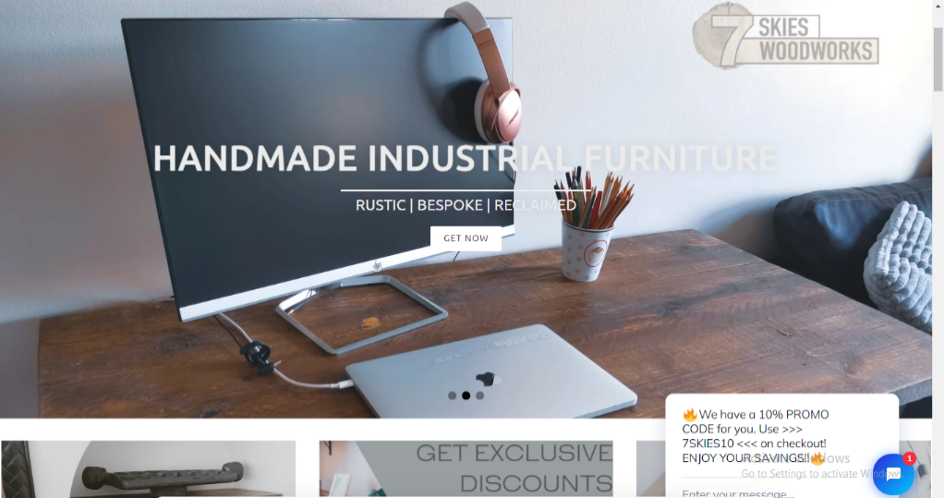

Product Features

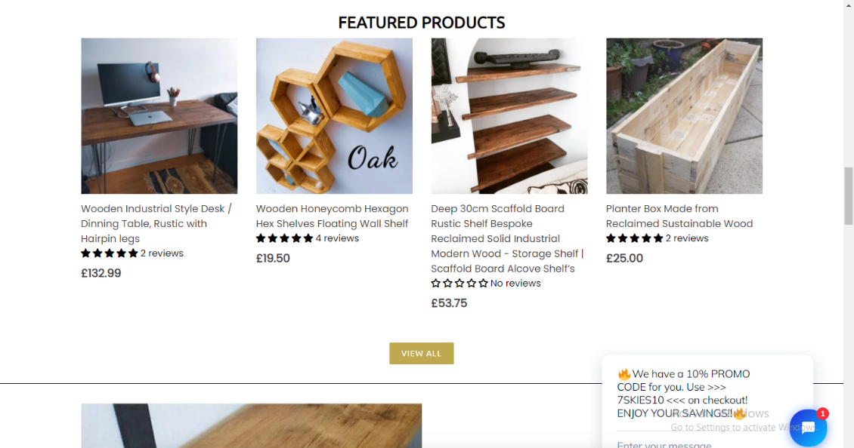

Product Page

